EXPERIMENT 1A
FIFA WORLD CUP 2026 PLAYER PERFORMANCE DATASET EXPLORATION

Aim
To load, explore and analyze the FIFA World Cup 2026 Player Performance dataset containing 54,600 records and 75 attributes using Python, Pandas and data analytics techniques.

Algorithm
Step 1: Load the Excel dataset into a Pandas DataFrame.
Step 2: Display dataset dimensions, columns and sample records.
Step 3: Check data types and missing values.
Step 4: Generate descriptive statistics.
Step 5: Analyze player performance metrics such as goals, assists and ratings.
Step 6: Visualize important trends using charts.

Program 1: Load Dataset
import pandas as pd
df = pd.read_excel("fifa_world_cup_2026_player_performance.xlsx")
print(df.head())

Program 2: Dataset Information
print(df.shape)
print(df.columns)
print(df.info())

Program 3: Descriptive Statistics
print(df.describe())

Program 4: Top Goal Scorers
top_players = df.groupby("player_name")["goals"].sum().sort_values(ascending=False).head(10)
print(top_players)

Program 5: Player Ratings Analysis
print(df["player_rating"].describe())

Program 6: Data Visualization
import matplotlib.pyplot as plt
df["player_rating"].hist()
plt.show()
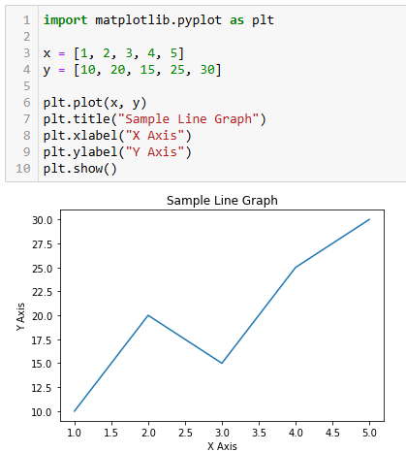
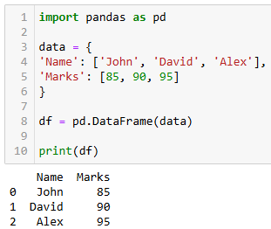
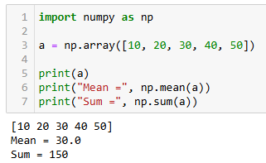
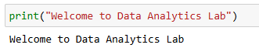
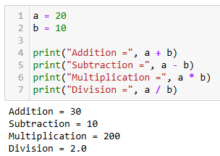
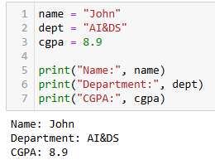

Dataset Summary
Total Records: 54,600
Total Attributes: 75
First Column: player_id
Last Column: tournament_rating

Result
Thus, the FIFA World Cup 2026 Player Performance dataset was successfully loaded, explored and analyzed using Python. Statistical analysis and visualization techniques were applied to understand player performance metrics.

